**Road Obstacles Detection using Deep Learning-based Systems in ADAS System**

A Project Report submitted in partial fulfillment of the requirements for the award of the degree of

**Bachelor of Technology**

### in

**Computer Science and Engineering**

by

### Shrunmay Shivaji Shinde (112115148):

**Under the Supervision of: Dr. Meenakshi Choudhary**

### Semester: Forth



#### Name of Department: Department of Computer Science and Engineering

#### 

#### Indian Institute of Information Technology, Pune

**(An Institute of National Importance by an Act of Parliament)**

#### April 2023

**BONAFIDE CERTIFICATE**

This is to certify that the project report entitled **“Road Obstacles Detection using Deep Learning-based Systems in ADAS System”** submitted by **Shrunmay Shivaji Shinde** bearing the **MIS No: 112115148**, in completion of his/her project work under the guidance of **Dr. Meenakshi Choudhary** is accepted for the project report submission in partial fulfillment of the requirements for the award of the degree of **Bachelor of Technology** in the **Department of Computer Science and Engineering**, Indian Institute of Information Technology, Pune (IIIT Pune), during the academic year **2022-23**.

#### Dr. Meenakshi Choudhary Dr. Sanjeev Sharma

Project Guide Head of the Department

Assistant Professor Assistant Professor

Department of CSE Department of CSE

IIIT Pune IIIT Pune

Project Viva-voce held on

**Undertaking for Plagiarism**

I **Shrunmay Shivaji Shinde** solemnly declare that research work presented in the **report/dissertation** titled **“Road Obstacles Detection using Deep Learning- based Systems in ADAS System”** is solely **my** research work with no significant contribution from any other person. Small contribution/help wherever taken has been duly acknowledged and that complete report/dissertation has been written by **me**. I understand the zero tolerance policy of **Indian Institute of Information Technology Pune** towards plagiarism. Therefore **I** declare that no portion of my **report/dissertation** has been plagiarized and any material used as reference is properly referred/cited. I undertake that if I am found guilty of any formal plagiarism in the above titled thesis even after award of the degree, the Institute reserves the rights to withdraw/revoke my **B.Tech** degree.

**Students’/ Student’s Name and Signature with Date**

**Conflict of Interest**

**Manuscript title: Road Obstacles Detection using Deep Learning-based Systems in ADAS System**

The authors whose names are listed immediately below certify that they have NO affiliations with or involvement in any organization or entity with any financial interest (such as honoraria; educational grants; participation in speakers’ bureaus; membership, employment, consultancies, stock ownership, or other equity interest; and expert testimony or patent-licensing arrangements), or non-financial interest (such as personal or professional relationships, affiliations, knowledge or beliefs) in the subject matter or materials discussed in this manuscript.

**Students’/ Student’s Name and Signature with Date**

## ACKNOWLEDGEMENT

This project would not have been possible without the help and cooperation of many. I would like to thank the people who helped me directly and indirectly in the completion of this project work.

First and foremost, I would like to express my gratitude to our honorable Director, **Prof. O.G. Kakde**, for providing his kind support in various aspects. I would like to express my gratitude to my project guide **Dr. Meenakshi Choudhary**, **Department of CSE**, for providing excellent guidance, encouragement, inspiration, constant and timely support throughout this **B.Tech Project**. I would like to express my gratitude to the **Dr. Sanjeev Sharma**, **Department of CSE**, for providing his kind support in various aspects. I would also like to thank all the faculty members in the **Department of CSE** and my classmates for their steadfast and strong support and engagement with this project.

Road Obstacles Detection using Deep Learning-based Systems in ADAS system

## TABLE OF CONTENTS

**Abstract 1**

**(i) List of Figures 2**

**(ii) List of Tables 3**

1. **Introduction 4**

1.1 Overview of work 4

1.2 Motivation of work 4

1.3 Literature Review 5

1.4 Research Gap 6

1. **Problem Statement 7**

2.1 Research Objectives 7

2.2 Methodology of work 7

1. **Analysis And Design 10**
2. **Results and Discussion 11**
3. **Conclusion and Future Scope 14**

**6 References 15**

**7 Publication (if any)**

# 

## Abstract

Road accidents have become a major reason for loss of lives. Nearly 1.35 million people worldwide had lost their life in road accidents. Majorly, this accidents happens due to bad condition of roads. Advanced Driver Assistance System (ADAS) is one way to guide the driver and also provides the base for development of Autonomous vehicles.

In this project, I am going to work on deep-learning-based approaches, namely deep feature extraction using Deep Learning algorithms, fine-tuning of pretrained convolutional neural networks (CNN) for real time classification of Normal road, Pothole and Speedbumps. For deep feature extraction, pretrained deep CNN models VGG16, ResNet50, Xception, InceptionV3, EfficientNetB6, EfficientNetV2B3, DenseNet169 were used. For classification of the deep features, our own customized classifier was used with various layers with 3 outputs. The pretrained deep CNN models were also used for Transfer Learning using Fine Tuning.

**Keywords:** Road Obstacles detection, Deep Learning, Transfer Learning

1

# List of Figures and Graphs

# Figure1]: Image Augmentation Using Keras

# Figure2]: Transfer Learning using fine tuning

# Figure3]: Flowchart of Proposed Model

# Figure4]: VGG16 accuracy and loss graphs

# Figure5]: ResNet50 accuracy and loss graphs

# Figure6]: Xception accuracy and loss graphs

# Figure7]: InceptionV3 accuracy and loss graphs

# Figure8]: EfficientNetB6 accuracy and loss graphs

# Figure9]: EfficientNetV2B3 accuracy and loss graphs

# Figure10]: DenseNet169 accuracy and loss graphs

# 2

# List of Tables

# Table1.]: Performance Comparison of various Convolutional Neural Network models implemented

# Table2.]:Performance comparison of our models with previous present models.

# 3

**Chapter 1**

**Introduction**

## Overview of Work

As the Automobile industry is recently shifting its focus to Autonomous vehicles, safety have become a vital factor to be considered .To achieve this, it is necessary to make Vehicle Control System comprehensively learn and analyze road conditions and take the actions which will not compromise the comfort of people sitting in the vehicle and thus to offer a smooth ride. There are limitations in detecting the road obstacles by driver and hence our project will also guide driver by displaying the obstacles on instrument cluster.

## Motivation of the Work

Studies have been actively conducted on AI technologies that assist and replace drivers to analyze road conditions data and support decision-making.

Since travelling determines a most important part in person’s life, Its safety and comfort must be given utmost importance. Automobile Industry’s confidence is increasing toward AI-based guidance technology with fast computational power and high accuracy based on learning done in earlier stages.

Autonomous Vehicle technology in AI is one of the fields with the most active research. Many studies are actively in progress because AI can recognize the characteristics of image data more accurately and faster than humans.

In particular, the recent outbreak of Autonomous Vehicles have increased the interest in development of detection methods using Artificial Intelligence.

Pretrained CNN models used for transfer learning using fine tuning in this project detects whether the road is normal or presence of potholes or speedbumps. This models are compared with the previously implemented models for proving their performance.

4

* 1. **Literature Review**

**[3]** The new novel neural architecture is implemented by this publication by adding some more convolutional layers for higher accuracy and the name of this model was MT_ResNet-26 . The new loss function was also implemented. The road conditions were detected and on the basis of that the speed and steering of vehicle was controlled. The accuracy obtained was 91%.

**[4]** Gaussian filter was used to remove the noise from image. Furthermore, Steerable filter was used for image enhancement and then Integral Projection image processing technique was used. Artificial Neural Networks and Least Squares Support Vector Machine(LS-SVM) are two AI approaches discussed. For Artificial Neural Network Approach, the accuracy is 85% and for LS-SVM, it is approx. 89%. This methods have been implemented mainly for detection of potholes.

**[5]** The model proposed is divided into 3 parts as Segmentation, Candidate region extraction and Decision. Binarization of input images takes place in Segmentation and further in Candidate part, the morphology filter is used for extracting darks regions for pothole detection. Candidate region is identified and decision is made on whether the pothole is present or not. The accuracy of proposed model is 73.5%.

**[8]** This paper have proposed the use of Resnet18-CBAM in smart cars for obstacle detection and avoidance task. For optimization of performance , the hyperparameters have been filtered and group with highest performance is selected. The car scored 72% accuracy which is better than the accuracies of existing methods.

**[11]** A 1D convolutional neural network was implemented and the images input was given by IOS smartphone mounted on the dashboard of the car. Accelerometer data was used for training. Although the model used for less computationally expensive, but it has given a test accuracy of 83%.

**[12]** This paper focuses on detection of speedbumps and potholes using the camera. An algorithm SSD (Single Shot Multibox Detector) is used. Rasberry Pi has been used as processing unit. The signals are send to speed controller unit of car to reduce the speed on detection of potholes or speedbumps. This paper summarizes the combination of an artificial intelligence based detection system in coordination with a microcontroller-based speed control system in a effective way to build self-driving cars.

5

* 1. **Research Gap**

Each of the model implemented in papers presented in literature review has its disadvantages.

The model used in [3] have more convolutional layers above the basic Resnet structure which makes the model highly expensive for computation. The model used in [4] uses Gaussian filter for image preprocessing which is time consuming and also some details are lost while reducing the noise. The model used in [5] first converts the image into binary form which is time consuming and morphology filter also makes the model complex. The accuracy obtained in [8] after filtering hyperparameters is 72% only. Similarly, the test accuracy obtained for model in [11] is 83% only. The SSD box used in [12] is not capable of performing well to small objects.

In our models, as we have used transfer learning, the time consumption is reduced to greater extent as it supports faster experiments. Also the computational power required is less than traditional CNN models as some of the hidden layers are pretrained on the weights on imagenet dataset itself. Although we are using Transfer learning with fine tuning, then also we are achieving better result than the earlier proposed models over the small dataset and unfreezing some of the layers by fine tuning do not cause more time consumption.

6

# Chapter 2

# Problem Statement

The biggest motivation of doing this paper is Now a days although autonomous vehicles are capable of detecting the lane markings and other vehicles/pedestrians on roads but they are not capable of detecting the obstacles on road like potholes and speedbumps. This reduces the level of ride comfort of passengers in vehicle. Thus, this paper implements various CNN models which will detect this road obstacles.

**2.1. Research Objectives**

Our Proposed models focuses on detection of road obstacles accurately using Convolutional Neural Network Deep Learning Algorithms and make driver or Electronic Control Unit aware of road conditions and helping them in decision-making to prevent the damage caused to vehicle and to prevent the reduction in comfort level of passengers.

**2.2. Methodology of the Work**

1. **Convolutional Neural Network models implemented**: VGG16, ResNet50, Xception, InceptionV3, EfficientNetB6, EfficientNetV2B3, DenseNet169.

2. **Dataset Preparation:**

i. Dataset for Pothole and Normal Road images is extracted from Kaggle and merged:

<https://www.kaggle.com/datasets/atulyakumar98/pothole-detection-dataset>

<https://www.kaggle.com/datasets/daviddjukic/pothole-detection>

ii.Dataset for images of Speedbumps collected from Mendeley Data:

<https://data.mendeley.com/datasets/xt5bjdhy5g/1>

iii. This datasets are then merged to form our customized dataset.

iv. Our Dataset is uploaded on Kaggle and can be accessed by:

<https://www.kaggle.com/datasets/shrunmayshinde/road-obstacles-detection>

v. Our Dataset consists of two directories: Training Set and Testing Set. Each of this directory is further having three classes: Normal, Pothole, Speedbump. Training Set consists of 1703 images belonging to 3 classes and Testing Set consists of 440 images belonging to 3 classes.

3. **Data Preprocessing**: Images are captured by Camera mounted on the front grill of the vehicle and fed to preprocessing. Defining the input image shape as 200 x 200 pixels. Implementing Image Augmentation using ImageDataGenerator method with attributes like rescale, shear_range, zoom range, horizontal flip, vertical_flip, rotation_range, fill mode, width_shift_range, height_shift_range, brightness range.

7

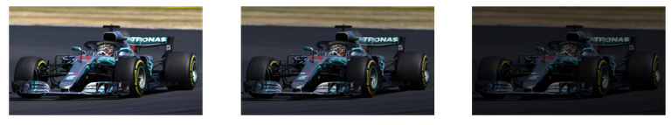a.)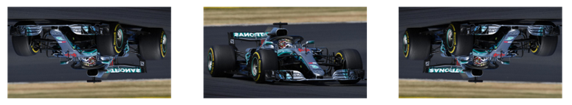b.)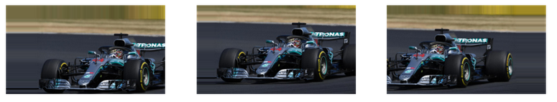c.)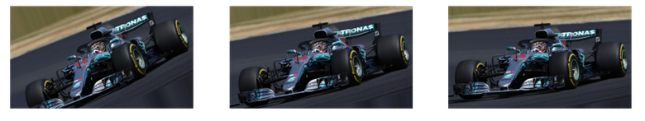d.)

Figure1: a.) brightness_range, b.) vertical flip, c.) width_shift_range, d.) rotation_range

(Figure1 shows a car image augmentation uploaded by Aniruddha Bhandari(2020) on AnalyticsVidhya)

**Source**: www.analyticsvidhya.com

3.**Transfer Learning and Fine Tuning**:

Loading the models from Keras official documentation: <https://keras.io/api/applications/>

Applying fine tuning and making some layers as trainable layers on our dataset.

Defining our own classification layer with three dense layers with activation function as relu for first two dense layers and activation function as softmax for last dense layers with three outputs. Applying 0.2 dropout method after the first two dense layers for deactivation of 20% nodes in each epoch.

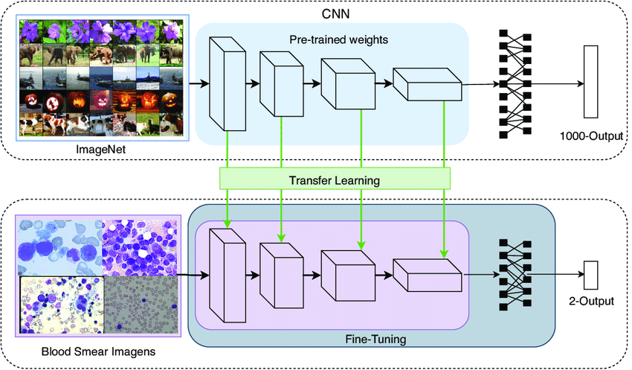

Figure2: Transfer Learning using Fine Tuning

(Figure2 shows the procedure of transfer learning using fine tuning and it was uploaded by Joao Manuel R.S. Tavares (2021) on researchgate)

**Source**: www.researchgate.net

4**. Model Training and Testing**:

Compilation of model using Stochastic Gradient Descent (SGD) as optimizer, categorical_crossentropy as loss function and Accuracy as metrics.

Using Reduced learning rate (reduced_lr) as callback method.

Training and testing the model with 70 epochs with 50 steps per epoch, using ‘shuffle’ attribute while 8 fitting the model.

5. **Performance measure used is Accuracy.**

6. **Printing the Accuracy vs epochs and Loss vs epochs graph using Matplotlib and Pyplot.**

9

# Chapter 3

# Analysis and Design

**Design of Our implemented model:**

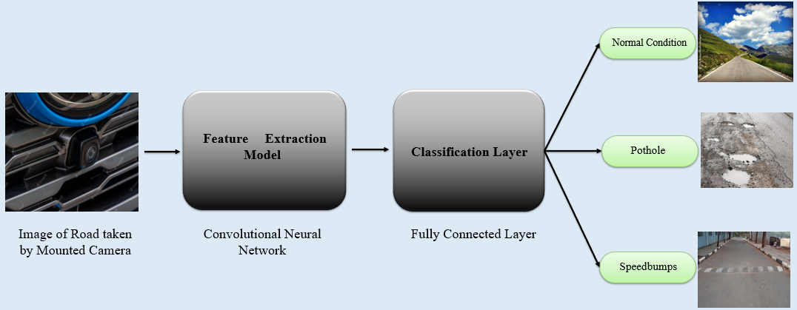

Figure3.] Flowchart of Proposed Model

1. The road image is taken by camera mounted at front grill of vehicle.
2. The image is set to input size of 200x200 pixels and is given as input to the Feature extraction model i.e Convolutional Neural Network.
3. The output from Feature Extraction Model is given as input to our classification layer.
4. Finally, the output layer classifies whether the road is normal/ pothole is present/ Speedbumps are present.

10

# Chapter 4

# Results and Discussion

The Accuracy vs Epochs and Loss vs Epochs graphs for each model implemented are as follows:

1. **VGG16:**

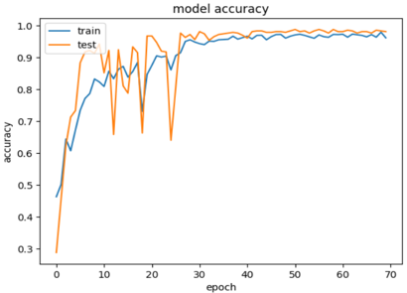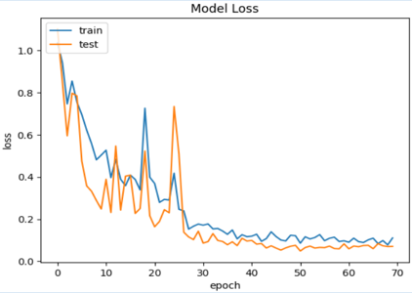Figure4]

1. **ResNet50**:

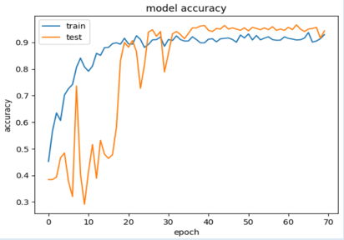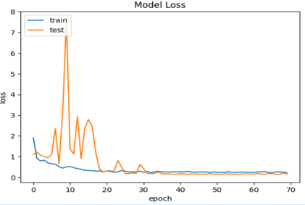Figure5]

1. **Xception:**

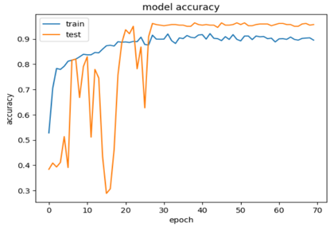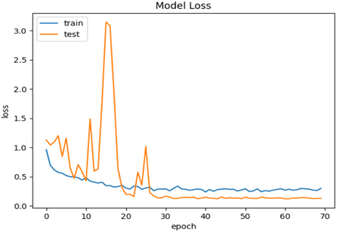Figure6]

11

1. **InceptionV3:**

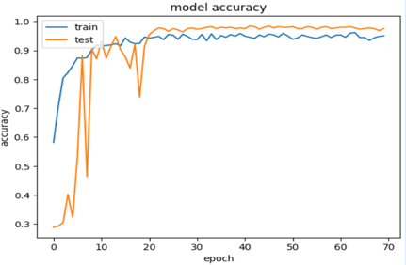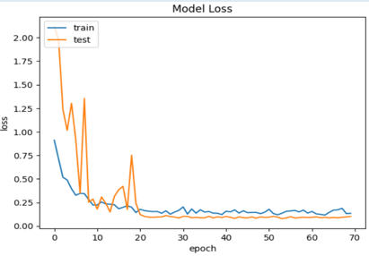Figure7]

1. **EfficientNetB6:**

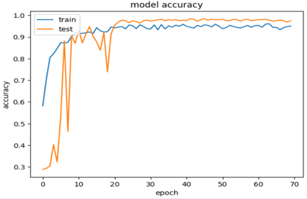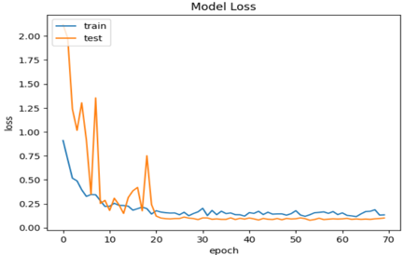Figure8]

1. **EfficientNetV2B3:**

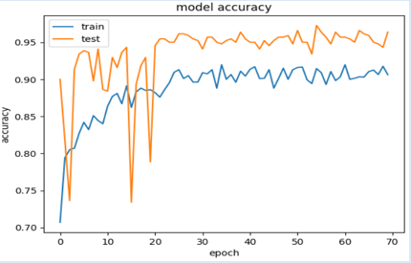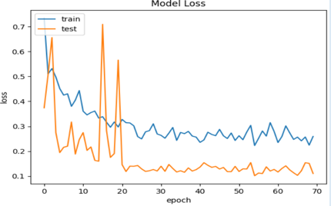Figure9]

1. **DenseNet169:**

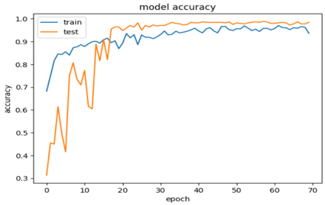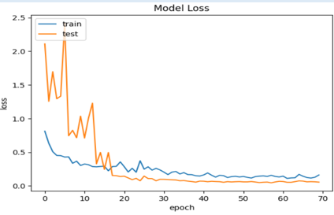Figure10]

12

**Accuracy comparison table for implemented models:**

|  |  |
| --- | --- |
| **Model** | **Accuracy** |
| VGG16 | 98.18% |
| ResNet50 | 94.32% |
| Xception | 95.68% |
| InceptionV3 | 94.77% |
| EfficientNetB6 | 97.50% |
| EfficientNetV2B3 | 96.36% |
| DenseNet169 | 97.73% |

Table1]

**Comparison with the existing models:**

|  |  |  |  |  |  |  |  |  |  |  |  |  |
| --- | --- | --- | --- | --- | --- | --- | --- | --- | --- | --- | --- | --- |
|  | Existing Models | | | | | Proposed Models | | | | | |  |
|  | MT-  Resnet26_  MSE_TRT | LS-SVM | Segment-  Candidate-  Detection | Resnet18-CBAM | 1D Convolutional Neural Network | VGG16 | ResNet50 | Xcepti-  on | Incepti-  onV3 | Efficie-  ntNetB6 | Efficient  NetV2B3 | Dense-  Net169 |
| Accuracy | 93% | 89% | 73.5% | 72% | 83% | 98.18% | 94.32% | 95.68% | 94.77% | 97.50% | 96.36% | 97.73% |

Table2]

13

# Chapter 5

# Conclusion and Future Scope

**Conclusion:**

Our proposed model takes a critical step towards improving the road safety and reduce the accidents caused by road obstacles. It also enhances the functionality of ADAS system and takes a bigger step towards developing the autonomous vehicles. The CNN models implemented have achieved a promising results, there is still room for improvement. We can refine our algorithms to reduce the false positives as well as false negatives, and integrate this system with Electronic Control Unit of vehicle to provide real-time alerts to drivers.

**Future Scope:**

The future scope of road obstacle detection technology in vehicles is promising, with advancements in sensor technology and more precise machine learning algorithms. Some of the potential areas of development are as follows:

1. **Integration with vehicle systems**: This will increase the safety by alerting the driver or ECU(in case of Autonomous vehicles) to slow down or change the lanes to avoid the potential hazards. It also reduces the vehicle damage caused by hitting the obstacles in high speed such as flat tires, bent wheels and suspension damage. The discomfort caused to passengers by jolting around in vehicle can be vanished by detecting the obstacles and adjusting the suspension accordingly. The system can also help drivers avoid obstacles by suggesting alternate routes.
2. **Vehicle to Vehicle (V2V) Communication:** When one vehicle detects a road obstacle, it can communicate this information to other vehicles in the vicinity, allowing them to slow down or avoid the hazard. This can help prevent accidents and improve overall safety on the road. Vehicle-to-Vehicle communication can help local governments and road maintenance crews identify areas that require repair more quickly and efficiently, reducing the risk of accidents and improving road conditions. Potholes can cause traffic congestion as drivers slow down to avoid them or navigate around them. By providing real-time information about potholes, vehicle-to-vehicle communication can help drivers choose the best route to their destination, reducing travel time and improving overall efficiency.
3. **Improving Precision of Machine Learning Algorithms**: Algorithms can be improved or refined to detect and classify road obstacles into various classes.
4. **Autonomous Vehicles:** Road Obstacles detection models can provide real-time monitoring of road conditions, which can help autonomous vehicles adjust their behavior in response to changing road conditions. For example, if a new pothole appears on the road, the vehicle can adjust its path or speed to avoid it. Road obstacles can cause significant damage to vehicles, which can be costly to repair. Obstacles can pose a significant hazard for autonomous vehicles, as they can cause damage to the vehicle's suspension and tires, as well as cause accidents. Road Obstacles detection models can help autonomous vehicles identify and avoid potholes, reducing the risk of accidents and damage to the vehicle. 14

**References**

**References for CNN Models Transfer Learning and fine tuning:**

[1] R. A. Nair, D. K. Suresh and R. D, "Predicting the Impact of Road Conditions on Battery Health Via Transfer Learning," *2023 Third International Conference on Artificial Intelligence and Smart Energy (ICAIS), Coimbatore, India, 2023*, pp. 1194-1200, doi: 10.1109/ICAIS56108.2023.10073732.

[2] Thu, May, Nikom Suvonvorn, and Nichnan Kittiphattanabawon. "Pedestrian classification on transfer learning based deep convolutional neural network for partial occlusion handling." *International Journal of Electrical and Computer Engineering (IJECE)* 13.3 (2023): 2812-2826.

**References for Previously Implemented models:**

[3] Zihao Nie and Jian Qu, “Multi-task Autonomous Driving Based on Improved Convolutional Neural Network and ST Loss in MTS and MOD Modes”, *Current Applied Science and Technology Vol. 23 No. 3*, 28 October 2022.

[4] Nhat-Duc Hoang, “An Artificial Intelligence Method for Asphalt Pavement Pothole Detection Using Least Squares Support Vector Machine and Neural Network with Steerable Filter-Based Feature Extraction”, *Hindawi Publication Corporation, Advances in Civil Engineering Volume 2018, Article ID 7419058*, 6 June 2018.

[5] Seung-Ki Ryu, Taehyeong Kim and Young-Ro Kim, “Image-Based Pothole Detection System for ITS Service and Road Management System”, *Hindawi Publishing Corporation, Mathematical Problems in Engineering Volume 2015, Article ID 968361*, 22 April 2016.

[6] Meyer, G.P. and Thakurdesai, N., 2020. “Learning an uncertainty-aware object detector for autonomous driving.” *Proceedings of the 2020 IEEE/RSJ International Conference on Intelligent Robots and Systems (IROS), Las Vegas, NV, USA, October 24, 2020 - January, 24, 2021*, pp. 10521-10527.

[7]Bechtel, M.G., McEllhiney, E., Kim, M. and Yun, H., 2018. Deeppicar, “A low-cost deep neural network-based autonomous car.” *Proceedings of the 2018 IEEE 24th International Conference on Embedded and Real-time Computing Systems and Applications (RTCSA), Hakodate, Japan, August 28-31, 2018.*

[8] Ding, S. and Qu, J., 2022. “Smart car with road tracking and obstacle avoidance based on Resnet18-CBAM.” *Proceedings of the 2022 7th International Conference on Business and Industrial Research (ICBIR), Bangkok, Thailand, May 19-20, 2022.*

[9] Yılmaz, E. and Tarıyan Özyer, S., 2019. “Remote and autonomous controlled robotic car based on Arduino with real time obstacle detection and avoidance.” *Universal Journal of Engineering Science, 7(1), DOI: 10.13189/ujes.2019.070101.*

[10] Banerjee, A., Bolar, V., Chaurasia, A., Maurya, S. and Gite, Y., 2020. “Autonomous driving vehicle.” *International Research Journal of Engineering and Technology (IRJET), 7(4),* 6048- 6050. 15

[11] Pandey, A.K., Iqbal, R., Maniak, T., Karyotis, C., Akuma, S. and Palade, V., 2022. “Convolution neural networks for pothole detection of critical road infrastructure.” *Computers and Electrical Engineering*, *99*, p.107725.

[12] A. Tithi, F. Ali and S. Azrof, "Speed Bump & Pothole Detection with Single Shot MultiBox Detector Algorithm & Speed Control for Autonomous Vehicle," 2021 International Conference on Automation, Control and Mechatronics for Industry 4.0 (ACMI), Rajshahi, Bangladesh, 2021, pp. 1-5.

**Citing an Image:**

Figure1] : Aniruddha Bhandari(2020). Image Augmentation using Keras.

1. <https://cdn.analyticsvidhya.com/wp-content/uploads/2020/08/brightness.png>
2. <https://cdn.analyticsvidhya.com/wp-content/uploads/2020/08/flip.png>
3. <https://cdn.analyticsvidhya.com/wp-content/uploads/2020/08/shift.png>
4. <https://cdn.analyticsvidhya.com/wp-content/uploads/2020/08/rotation.png>

Figure2: Joao Manuel R.S. Tavares (2021), Diagnosis of Leukemia in blood slides based on a fine tuned and highly generalizable deep learning model.

<https://www.researchgate.net/profile/Joao-Tavares-23/publication/351085550/figure/fig3/AS:1016156517310464@1619282001253/The-transfer-learning-and-fine-tuning-techniques-used-in-the-development-of-the-proposed_Q640.jpg>

16

Citation Examples: Patents

**Instructions**

1. All the pages should be numbered at the bottom right side of the page.
2. The formatting of dissertation/report should be in APA format.
3. All the References should be mentioned in the APA format.
4. All the tables and figures should be labeled. The compiled list of the tables and figures should be presented in the appendix.
5. The report should be original in its work. Only 20% of plagiarism is permissible. Students must attach an Undertaking for plagiarism report at the designated place of the report.
6. The students must get the report verified, evaluated and signed by the supervisor before its final submission in the spiral bound form and incorporate any changes, suggestions or recommendations as directed by the supervisor.
7. The students should bring the final report (spiral bound) on the day of End-Semester Project Presentation and submit it to their respective panelists.
8. The format of BTP/MTP report shared should be strictly followed.
9. The Problem Statement and Objectives submitted during the Mid-Term Presentation must be attached to the Final report after the Bonafide certificate given in the sample report.
10. The **order of report** should be in the following format:
11. Title Page
12. Bonafide Certificate, Conflict of Interest and Undertaking for Plagiarism
13. Problem statement and objectives submitted during the Mid-Term Presentation (**Internship** students should skip this section)
14. Abstract with keywords
15. Contents
16. Chapters as suggested in report

11. All the data/tables/figures taken from other sources should be duly credited in the footnotes or references.

12. The font size should be 12 throughout the document. The title should be Font size 17 and sub-heading should be Font Size 14, followed by under subheadings as Font Size 12. The Font Style must be **Times New Roman Only** and spacing between each line must be 1 and between headings should be 2.

13. The spacing between each line must be 1.15 and between headings must be 2.

14. All the paragraphs must be aligned as “justify” while the headings must be in center, the sub-headings should be left aligned.